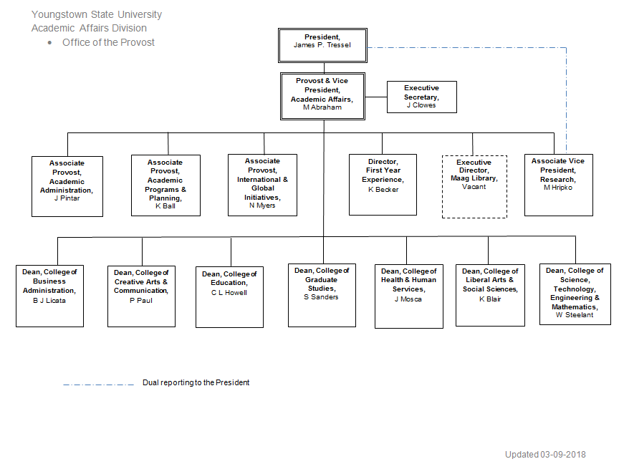
Org Chart for Youngstown State University
Academic Affairs Division
Office of the Provost

The President, James P. Tressel, oversees the Provost and Vice President, Academic Affairs, M Abraham
The Provost and Vice President, Academic Affairs, M Abraham has multiple direct reports as follows: Executive Secretary, J Clowes; Associate Provost, Academic Administration, J Pintar; Associate Provost, Academic Programs and Planning, K Ball; Associate Provost, International & Global Initiatives, N Myers; Director, First Year Experience, K Becker; Executive Director, Maag Library, Vacant; Associate Vice President, Research, M Hripko; Dean, College of Business Administration, B J Licata; Dean, College of Creative Arts and Communication, P Paul; Dean, College of Education, C L Howell; Dean, College of Graduate Studies, S Sanders; Dean, College of Health and Human Services, J Mosca; Dean, College of Liberal Arts and Social Sciences, K Blair; and Dean, College of Science, Technology, Engineering and Mathematics, W Steelant
Associate Vice President, Research, M Hripko also has dual reporting to the President, James P. Tressel

Org Chart last updated March 9, 2018

