YOUNGSTOWN STATE UNIVERSITY
Graduate Council Meeting
Wednesday, March 29, 2023
TEAMS – 4:00 pm

Attending: Valerie O’Dell, Chair, Patrick Bateman, Christopher Bellas, Joseph W. Carucci, Kendra Fowler, Douglas Genna, Jake Protivnak, Virgil Solomon, Sal Sanders, , Linda Hulburt Blosser

Not Attenting: Lauren Cummins, Paul Louth, Angie Urmson Jeffries GSAC: Alyssa Osman

Guest: Hillary Fuhrman, Asst Provost Teaching Learning

The Chair, Valerie O’Dell called the meeting to order when the required faculty signed in.

- Noel Levitz Testing – Overview of report/results – Hillary Fuhrman

Hillary Fuhrman explained that she oversees the YSU Institute for Teaching and Learning ITL and sends out updates. Her office handles the assessment of student learning for academic programs and curricular programs and two main surveys, the National Survey of Student Engagement and an undergraduate survey.

Her presentation included (14) fourteen key topics of discussion. The Graduate Faculty had some questions and shared some real concerns. The Graduate Council members found this very interesting and asked they be provided with a copy of this report to review and discuss. Please see Attachment #1

- February 2023 meeting minutes evote approved (7 Approve, 0 Approve with edit, 0 Abstain)

- Committee Chair reports
  - Admission and Appeals Committee Chair: J. Paul Louth
No report was received from J. Paul Louth.

b. Graduate Curriculum Chair: Virgil Solomon-
There were no items to report.

c. Exceptions Chair: Sal Sanders
The Exceptions Committee had a request for one exception to admit a student to the MBA program who did not meet the GPA criteria. The exception was granted largely due to the person’s extensive work experience.

  - Grievance Chair: Christopher Bellas
Christopher Bellas had nothing to report.

  - GSAC- Marina Merlo and Alyssa Osman
Marina Merlo had nothing new to report.

- FYI, the Graduate GPA Recalculation policy evote was approved.
(6 Approve, 1 Approve with edit, 0 Abstain) See the Policy below.

- Discussion of adding maternity leave to the GA leave policy
(Current GA leave policy below) - Doug Genna

Doug Genna said the students on assistantships get two weeks paid and they have to declare that before they leave.

Sal Sanders said the reason for the short-term leave was that if a student was interrupted from completing their duties for two weeks, we could go ahead and pay them and there would be time for them to make up some of those hours.

This seemed like a reasonable time that could be accommodated, and they could make up some of those hours without going over those 25 hours by the end of the term, so we could continue to pay them.

Because we’re going to have to get someone else to do that work and we need the resources to cover that. We do not have the financial resources to pay for them.

Douglas Genna stated that we should have a more compassionate policy and give them six weeks as a minimum and other council members agreed with this.

Sal Sanders asked what if we make it six weeks for maternity leave, it could be used for anything else. If somebody gets in a car accident or whatever, you could get paid universally for anything and not just for maternity leave. We do not have a very good policy for Graduate Assistants compared to other places. A lot of places give them medical insurance and all sorts of other coverage. We now offer them parking fees.

This has been managed in the departments. Sal said he would explore with others and the provost to get some recommendations.

- Recommendation to replace recommendation letters from admission requirement to names of references only – Sal Sanders
One of the things is that a lot of our students, after getting admitted and having their applications reviewed, are waiting on people to write them letters of recommendation. I don’t want to hold up their admission any longer for items that are out of the student’s control. We’ll just ask the student for contact information and the department can still follow up on the letter if they want. I am asking for an operational change here.

It is important to be sure to check all references, so the student is not biased against another student. You have to do this for all applicants not just the ones you want to zone in on.

It is recommended that programs can request contact information in a life of references, but we will not require letters for the assistantships or for admissions. The programs are not required to get those names either. Valarie O’Dell asked for a motion to change this current operational requirement. The motion passed with all those attending this meeting voting for this change with 0 opposed and 0 abstaining.

GRADUATE GPA RECALCULATION FORM
Request a recalculation of your GPA after repeating a course.
Beginning Fall 2023, current graduate students may improve their Grade Point Average (GPA) by repeating a course in which a grade of “B”, “C”, "D" or "F" was earned and requesting a recalculation of their GPA using the higher grade that was earned when the class was repeated.
In order to recalculate the GPA, the repetition must be consistent with the policy on course repetition (detailed below), and the student must initiate the recalculation process with the approval of their Graduate Program Director.
The course grade will be excluded from the GPA, but the letter grade will remain on the official transcript and be noted with an “R” indicating the course has been repeated.
Only students currently attending the University may request this recalculation privilege. Only courses taken at Youngstown State University may be used for the recalculation process (both the original and subsequent course). The Recalculation form and the Petition for a Late Withdrawal cannot be used for the same course.
Only one GPA recalculation for any course will be applied to the student’s transcript record. The course repetition policy limits students to taking a course no more than twice. Students whose degree (undergraduate or graduate) has been conferred cannot repeat a course for recalculation of the student’s GPA.
The GPA can be recalculated for up to three courses.
All GPA recalculations completed as a result of the GPA Recalculation form Option are final and cannot be reversed. Once your degree has been conferred a GPA Recalculation form cannot be submitted as the academic transcript (grades and other notations) is finalized when a degree is posted to the permanent record.
Some graduate programs may not permit the repetition of some courses for the purpose of recalculation of a student’s GPA. Submission of the GPA Recalculation form does not guarantee approval.

Guidelines for YSU Graduate Assistant Leave

Circumstances occasionally occur that prevent graduate assistants (including GAs, TAs, and GAIs) from performing the duties of their appointment. Consistent with Youngstown State University’s effort to support all members of our community, these guidelines seek to reduce the professional and personal stresses that can develop when graduate assistants encounter extenuating circumstances that warrant a temporary absence from their assistantship duties. The purpose of these guidelines is to outline how instances of personal and/or family illness, injury, childbirth or adoption, and other agreed-upon and valid reasons for absence should be addressed by the unit funding the assistantship. These guidelines are intended to ensure that graduate assistant support is maintained to the extent possible during an approved absence. In the case of foreseeable events, the graduate assistant should inform his/her direct assistantship supervisor as soon as the circumstances and dates of needed leave are known. For unforeseeable events, notification should be made as soon as possible once the need arises. It should be noted that leave requests may be jeopardized or denied for reasons including, but not limited to, multiple leave requests, unsatisfactory performance levels, evidence of dishonesty, and insufficient documentation. Furthermore, these guidelines pertain only to issues related to the individual as a graduate assistant. There are separate attendance policies for the individual as a graduate assistant at YSU.

Short-term graduate assistant absences may be requested for valid periods of absences which typically span less than two weeks in duration. In these instances, the graduate assistant should make the request to his/her direct assistantship supervisor as promptly as possible, so that coverage of duties during the requested short-term absence can be addressed. Reasonable requests for short-term absences can typically be approved with all graduate assistant benefits maintained. The graduate assistant should work with the direct assistantship supervisor and the department chair to ensure that the time can be made up in a reasonable manner through creative ways such as working up to an extra five hours per week, working over university breaks, etc. The graduate assistants, the direct assistantship supervisor, and the department chair should agree to this plan in writing through the Short Term/Extended Leave Form (See Below).

For absences from graduate assistant duties of longer than two weeks, a graduate assistant must formally request extended leave. Long-term absences may be requested for a variety of valid reasons as previously noted. These types of requests should be reasonable and include written documentation related to the reason for absence (such as a letter from a medical doctor, legal documentation, etc.). The request for extended leave must be made to the chair of the department providing the assistantship in consultation with the direct assistantship supervisor. Whenever possible, the department chair should not reassign the workload to another graduate assistant. Graduate assistants who are formally approved through the Short Term/Extended Leave Form will be excused from their regular graduate assistant activities for the duration of their approved leave. Although tuition remission will continue during the extended absence, graduate assistants will no longer receive the monthly stipend for the duration of their approved leave. The graduate assistant’s monthly stipend resumes upon successful return to the graduate assistant position within the particular appointment period. Should the graduate assistant require additional leave time beyond the original agreement, this must be formally approved by the department chair in consultation with the direct graduate assistant supervisor through the Short Term/Extended Leave Form. Should the graduate assistants be unable to return until after the original appointment ending date, there is no guarantee of the availability of a continued graduate assistantship. However, the graduate student would be considered for future graduate assistant appointments in a manner consistent with all other graduate students.

_____________________________________________________________________________________

Graduate Assistant (GA, TA, GAI) Leave of Absence Form

Graduate Assistant Name: _________________________Y#:________________

Academic Program:____________________Email Address:___________________

Leave Requested (select one):
_____Short Term Absence (less than 2 weeks)_____ Extended Leave of Absence:

Reason for Leave:__________________________________________________________
______________________________________________________________________________
Dates of Leave: (Starting Date and Anticipated Ending Date)
______________________________________________________________________________
Impact of Leave (Description should include the department name and duties/responsibilities performed by the assistant):___________________________________
_____________________________________________________________________________

____Approved ___Not Approved Assistantship Supervisor Signature:_____________

____Approved ___Not Approved Chair Signature:___________________________________

Chair’s plan of action to reassign duties (Extended Leave of Absence only)____

__________________________________________________________________________________________

____Approved ___Not Approved College Dean Signature:_________________________

____Approved ___Not Approved Graduate College Dean Signature: ______________

Submit the completed form to Graduate College for final approval and distribution of the approved form to the student, supervisor, chair, and college dean.

Guest: Hillary Fuhrman. Ms. Hillary Fuhrman. Asst Provost Teaching Learning. Contact me. hlfuhrman@ysu.edu. Jones Hall 3048A. 330-941-2453.

Noel Levitz Testing – Report – Scanning 1-14 items.

________________________________________________________________________________

The following are Hilary Fuhrman’s (14) items in her PowerPoint presentation:

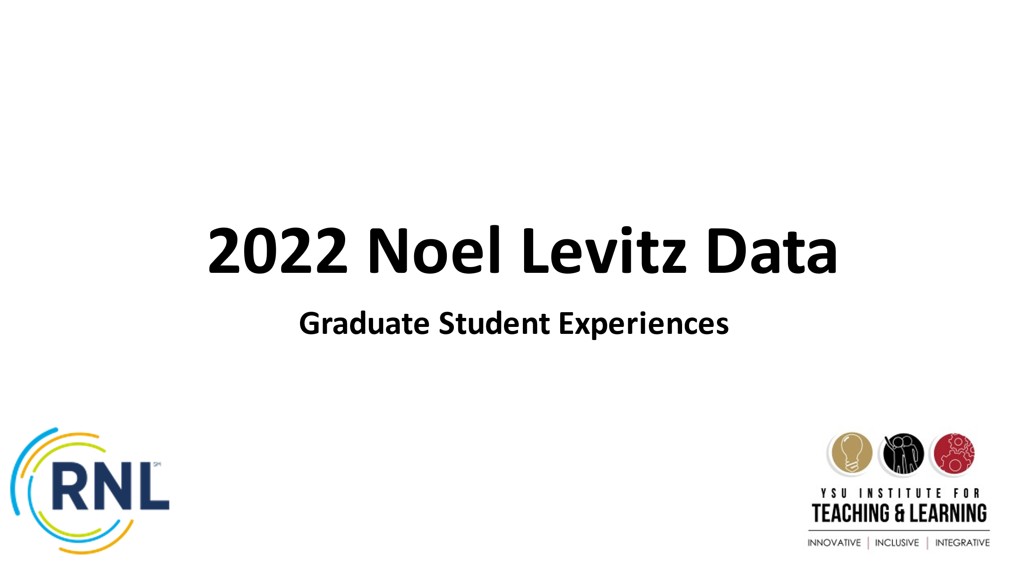

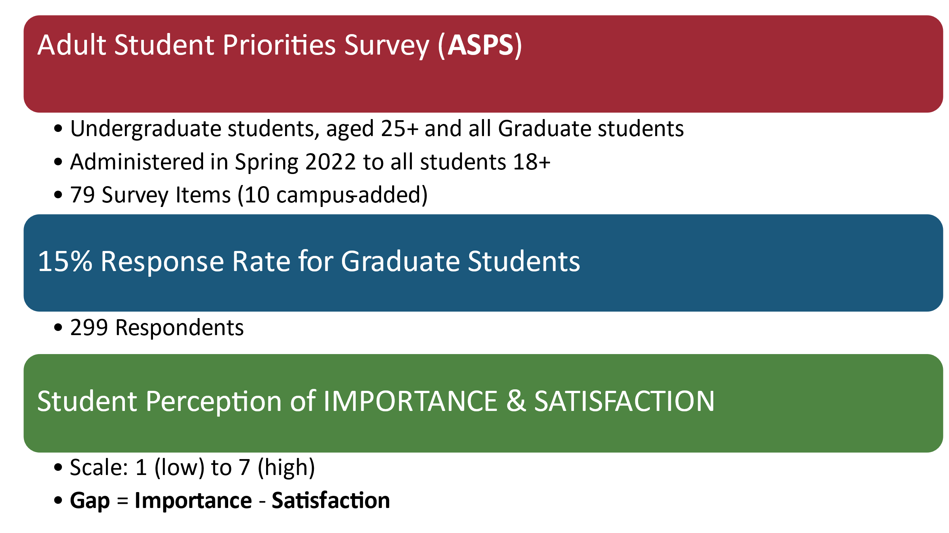

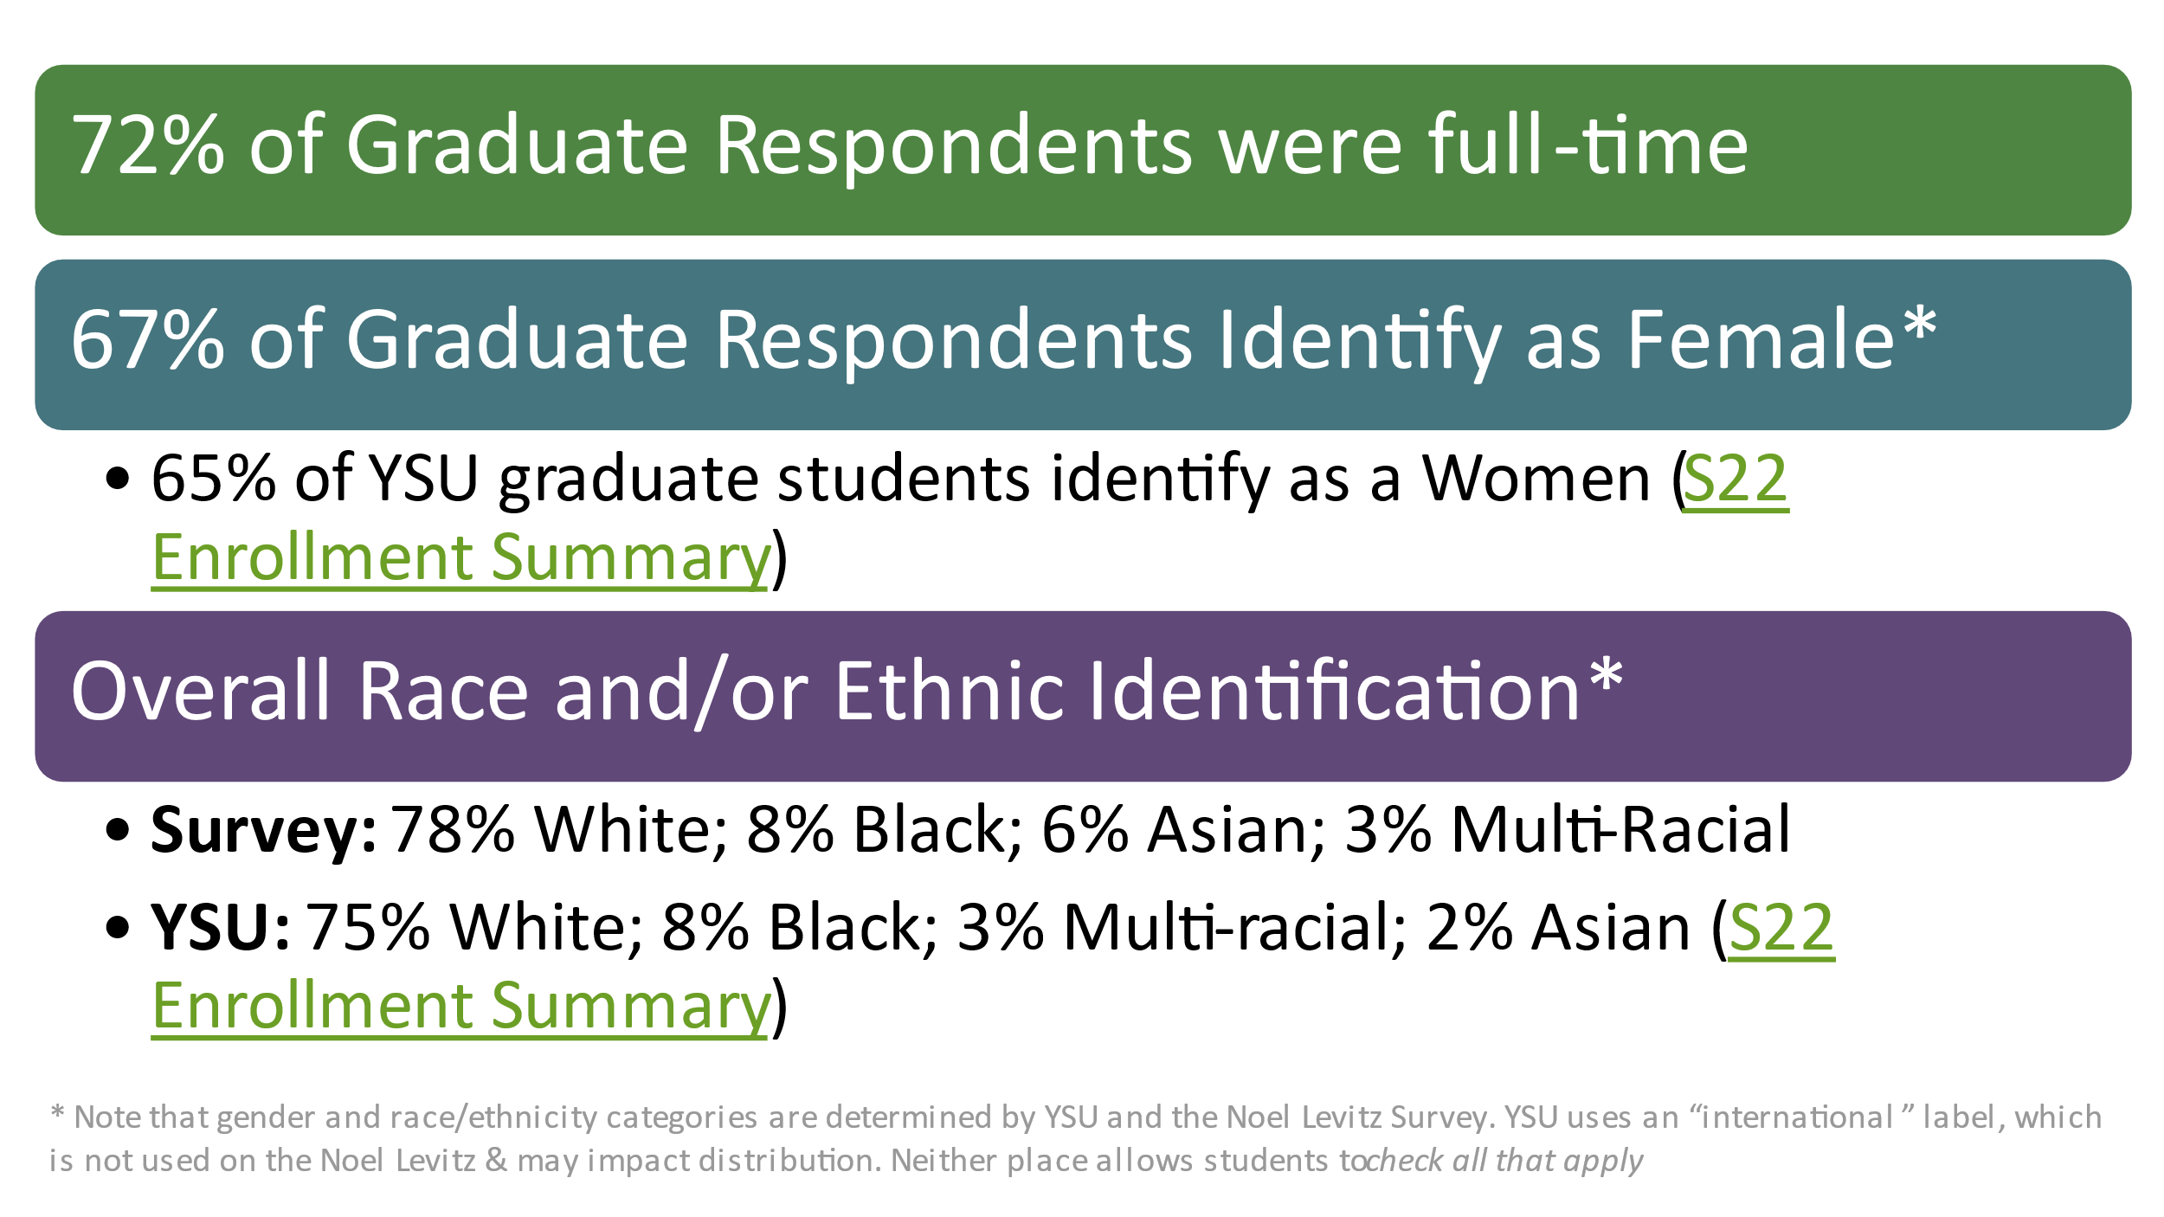

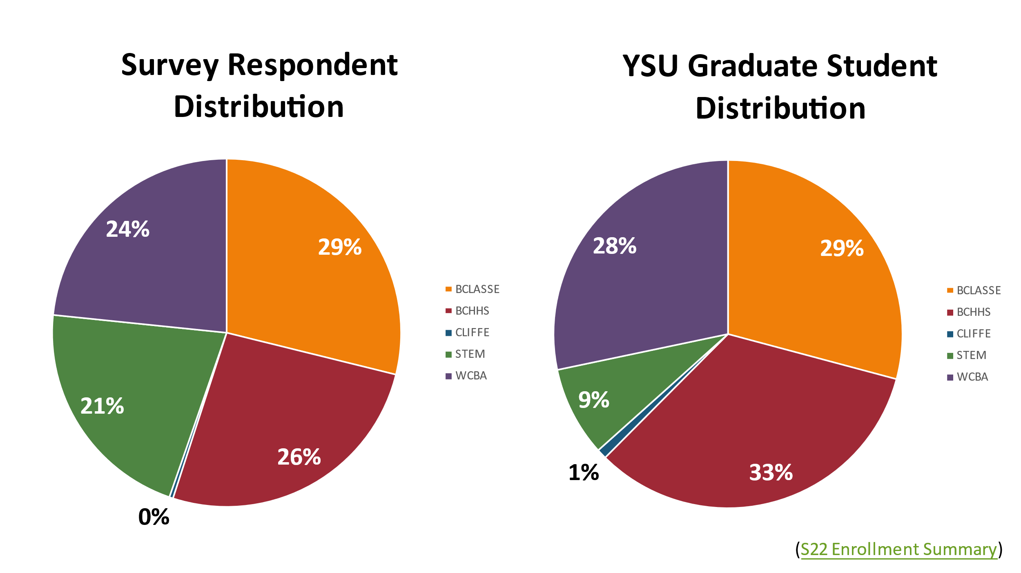

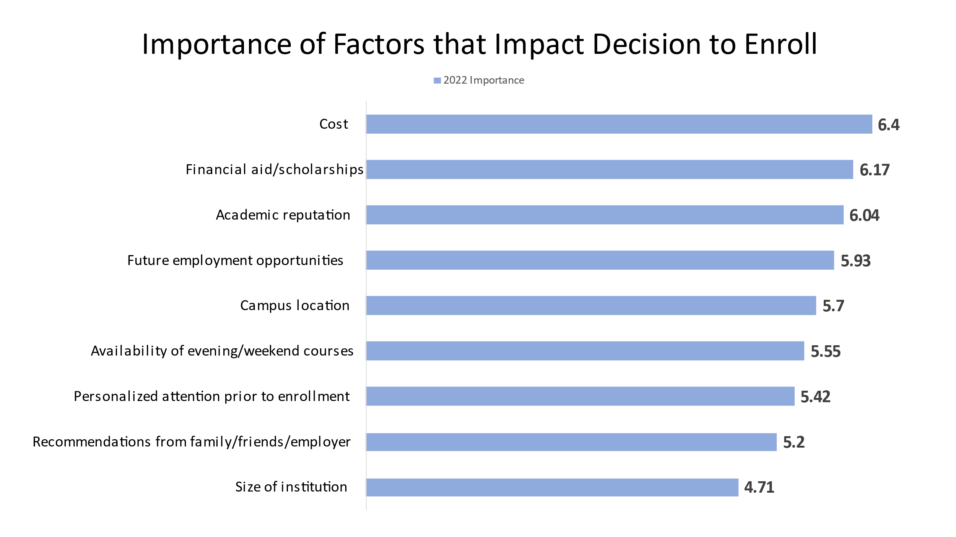

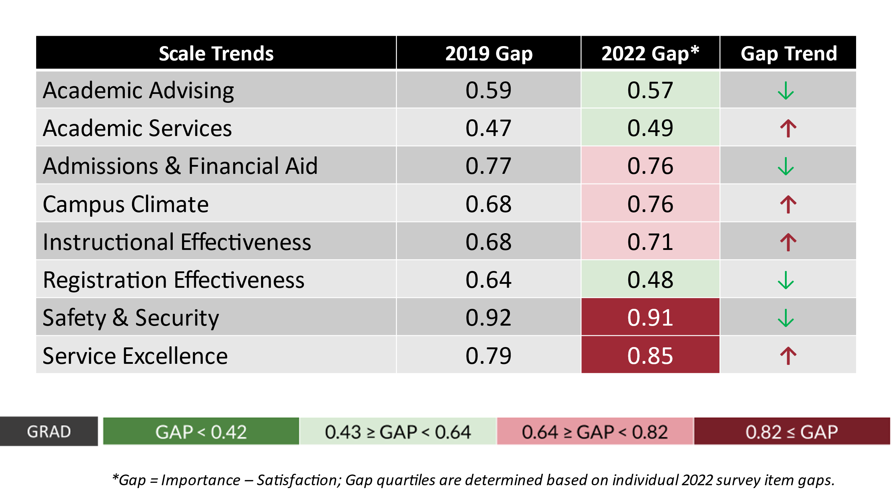

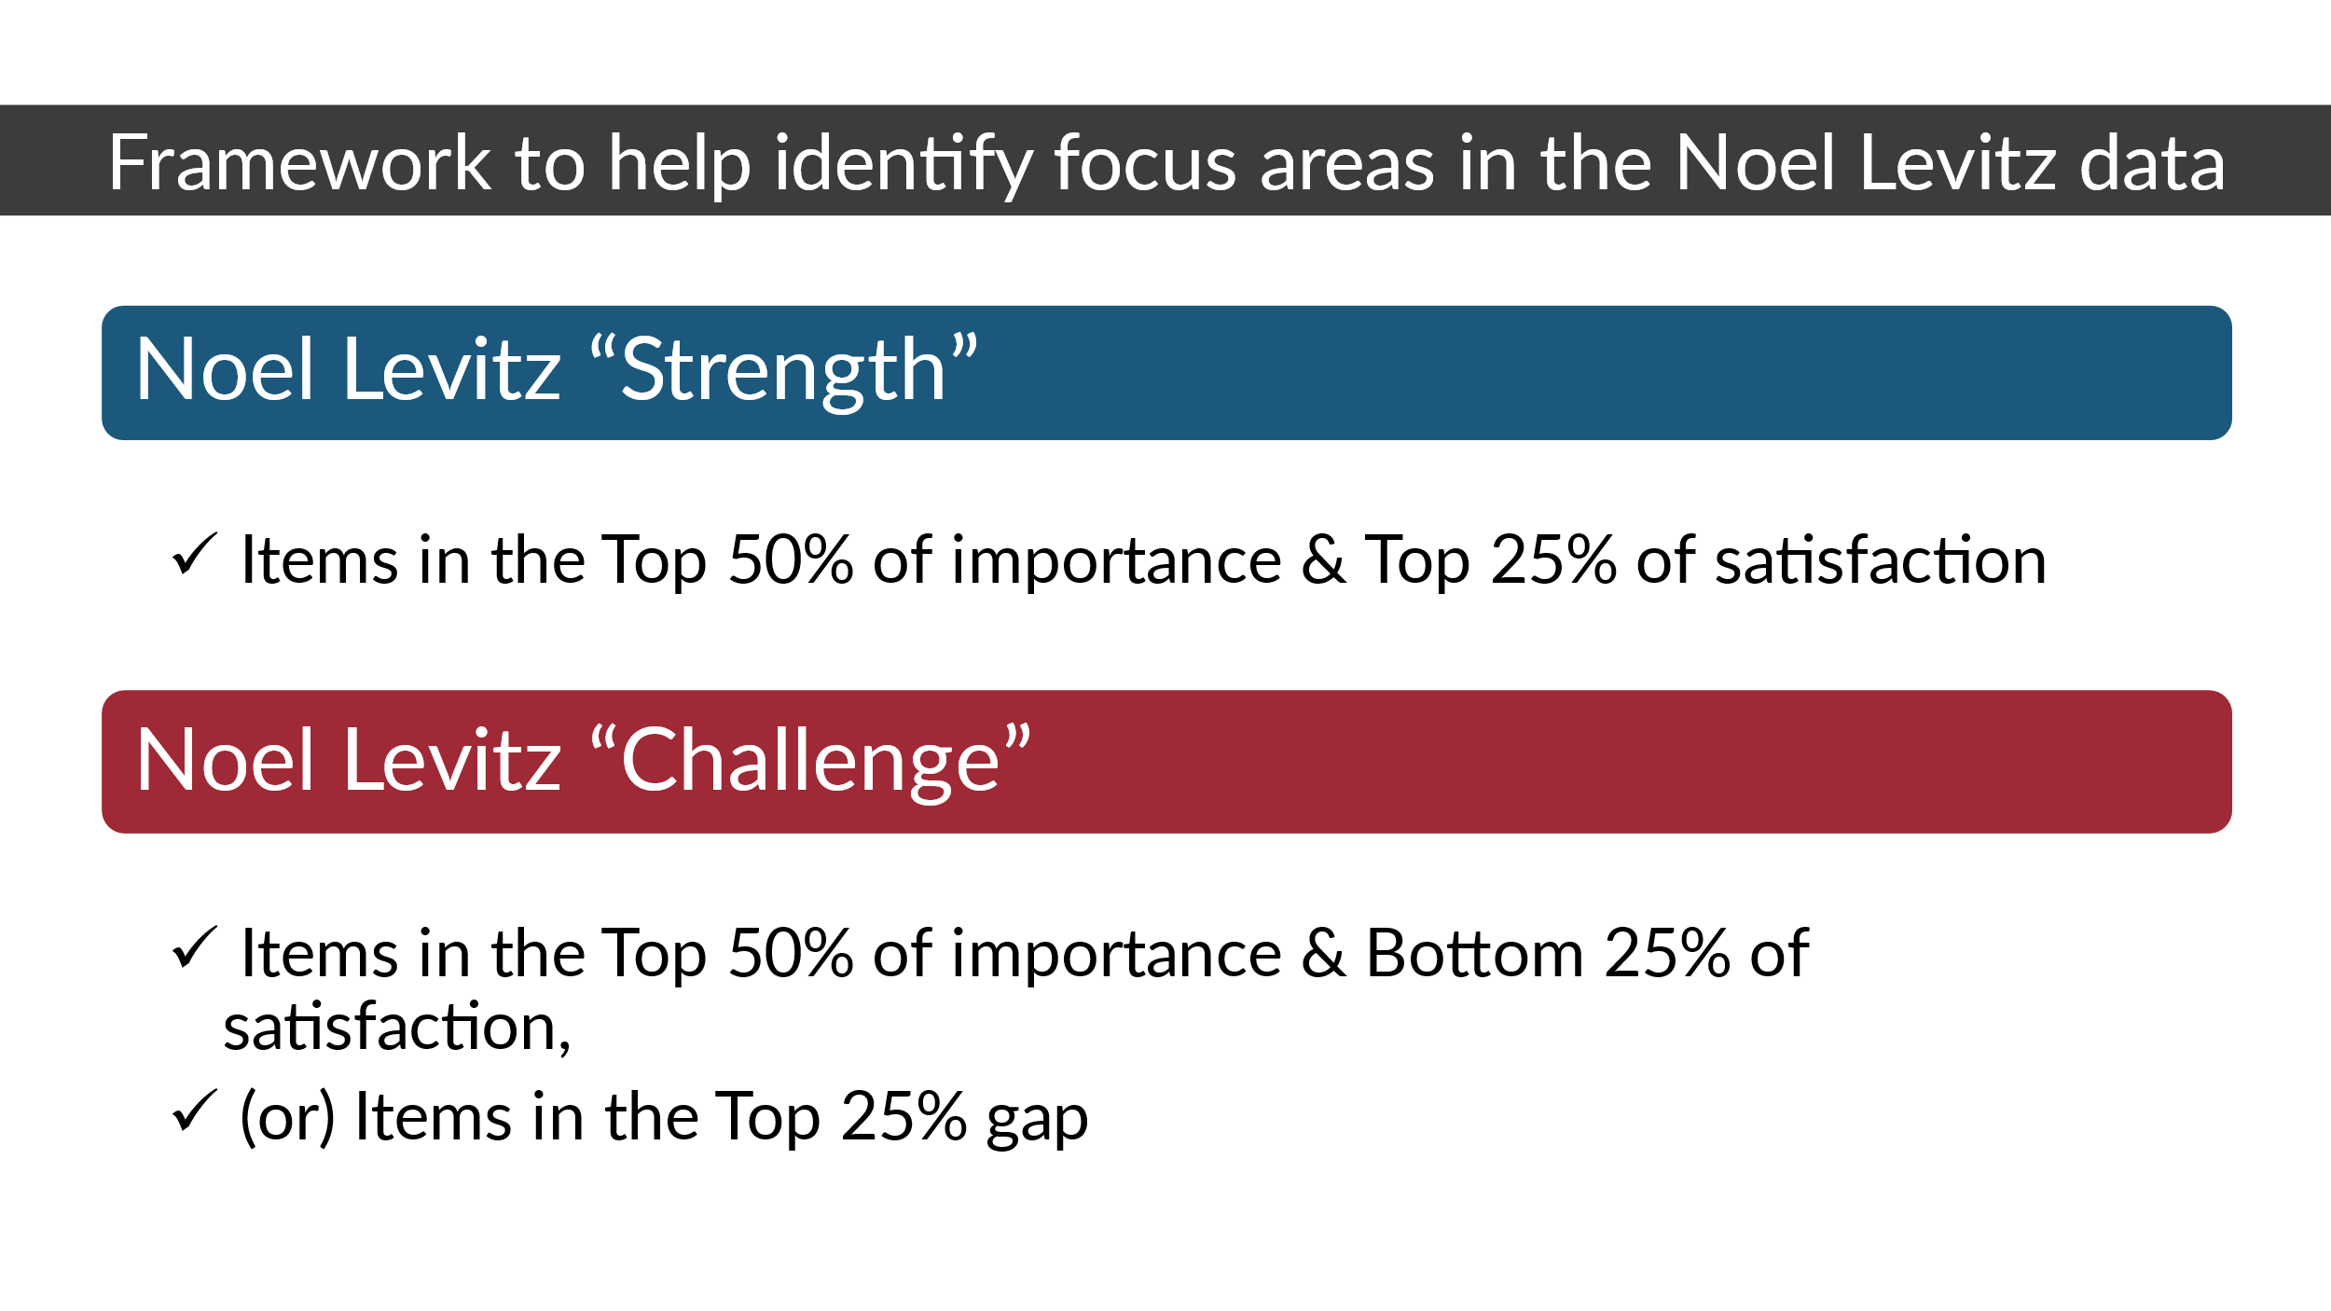

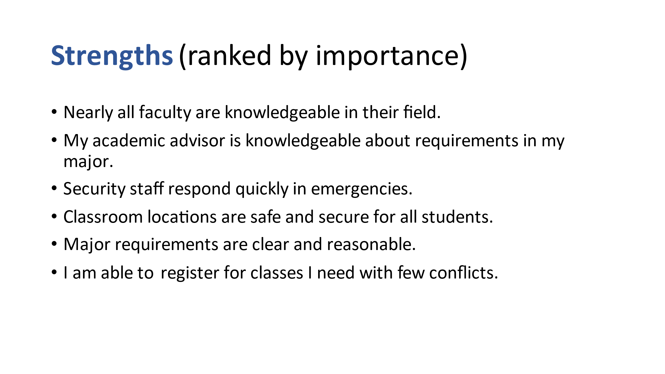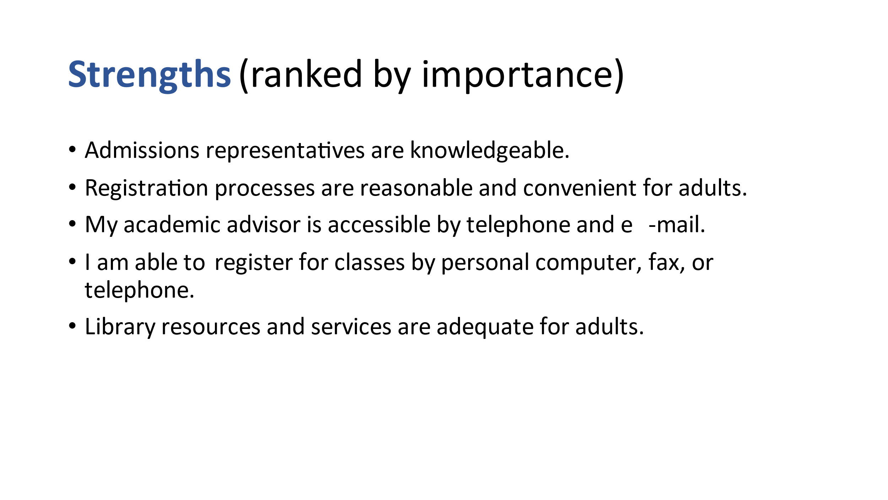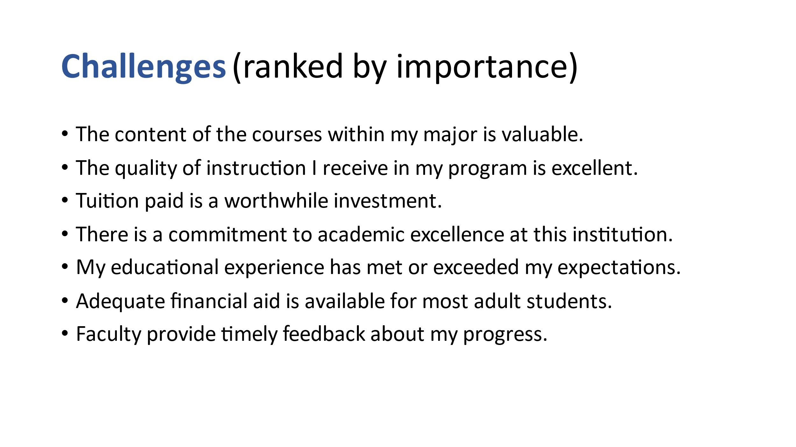

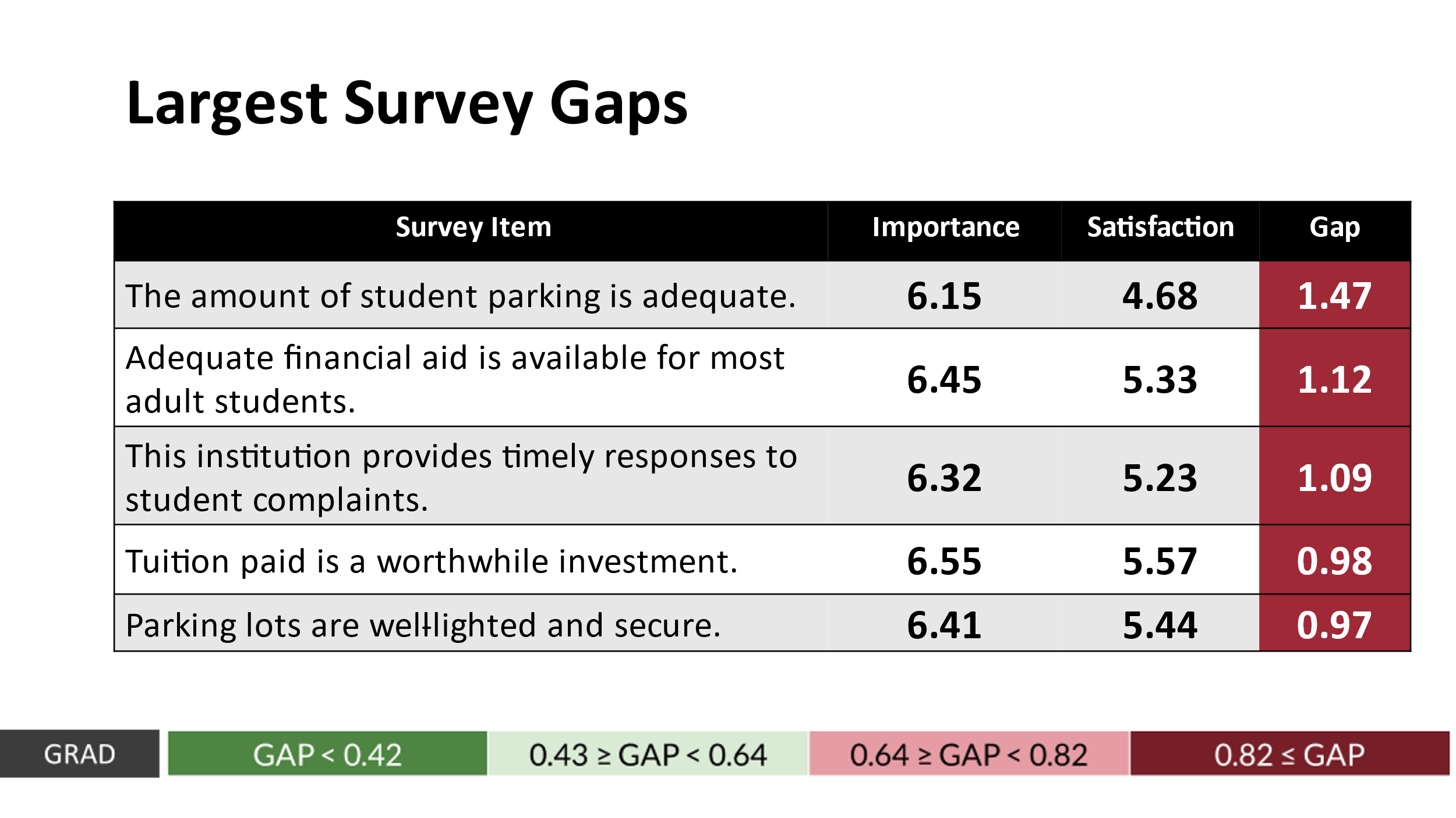

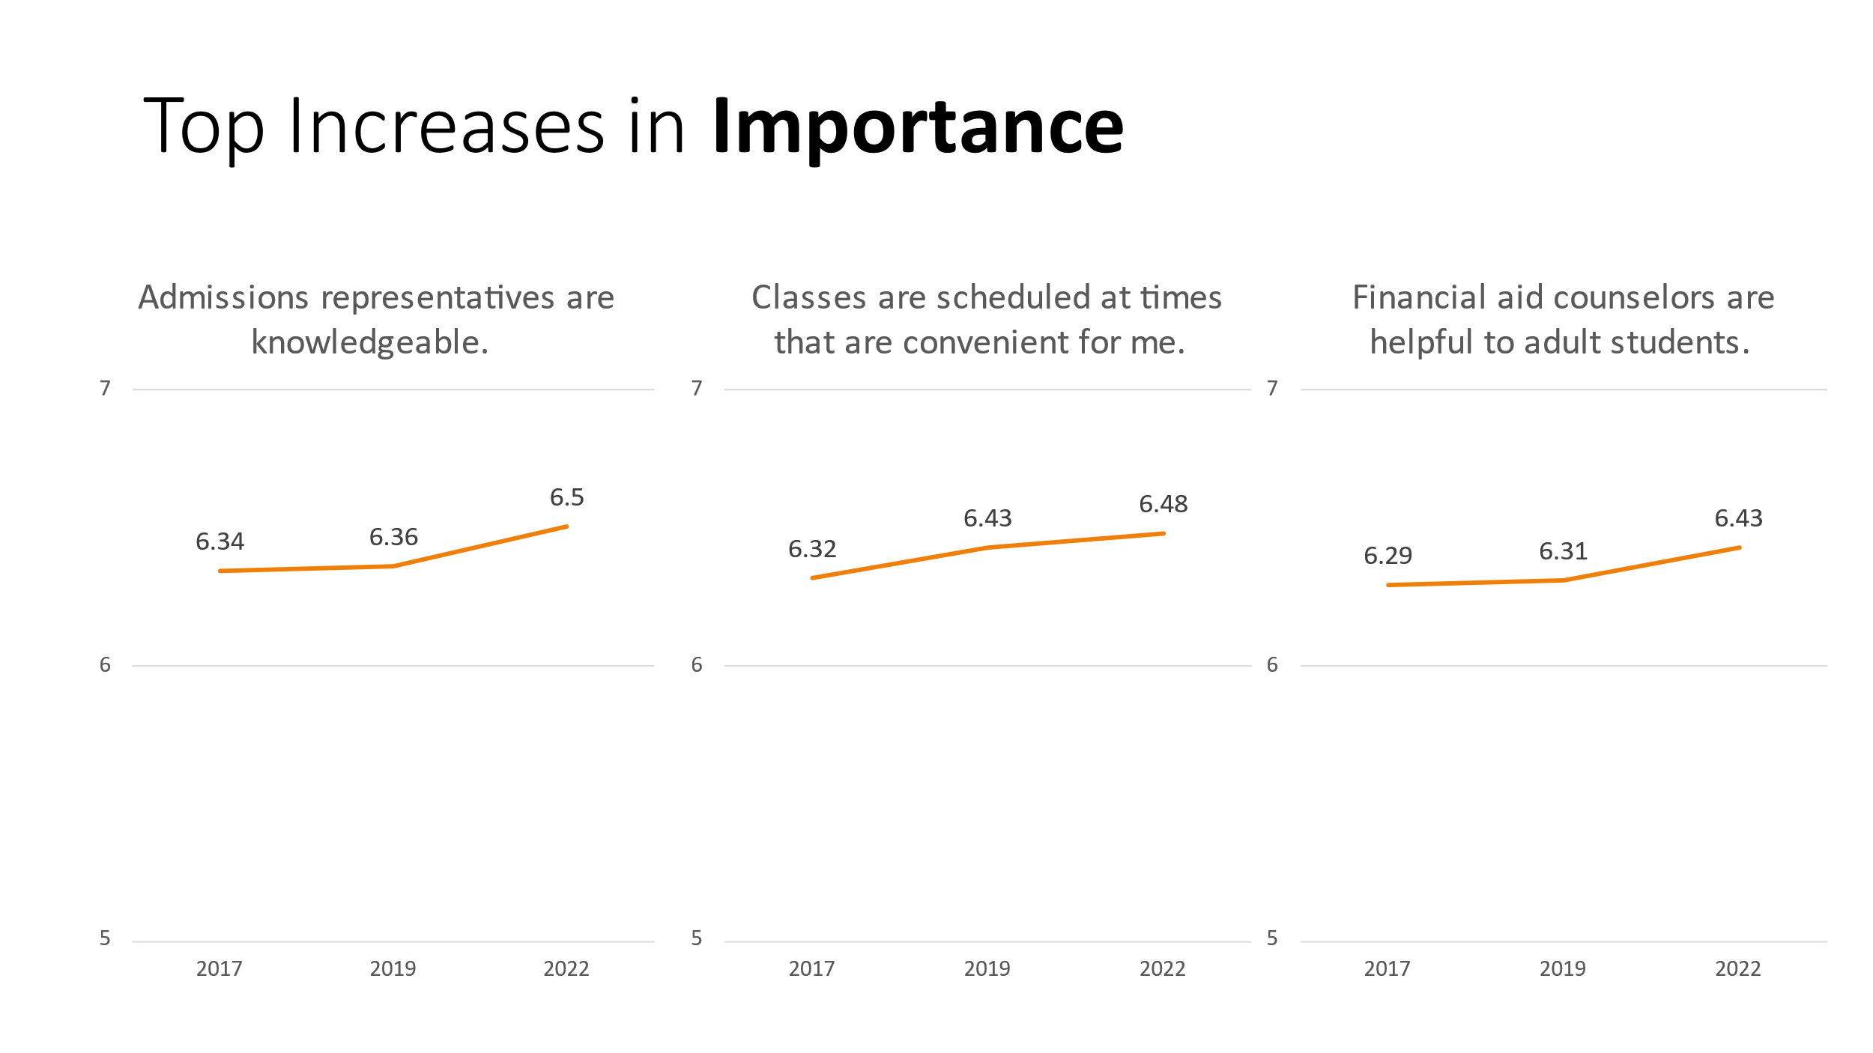

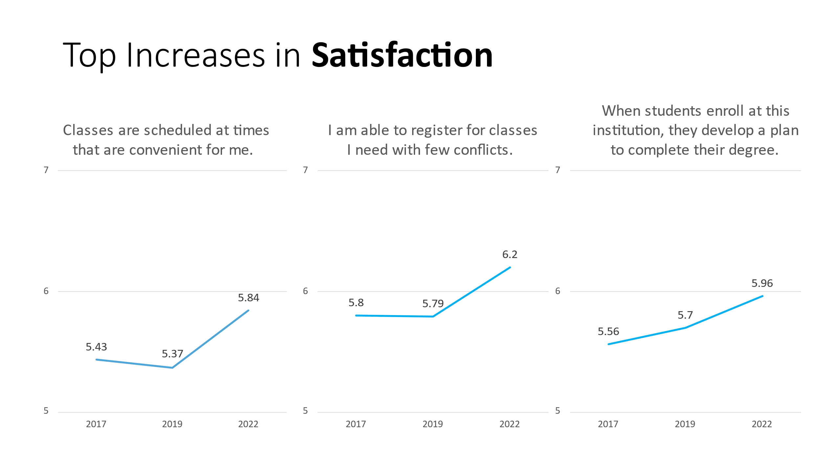

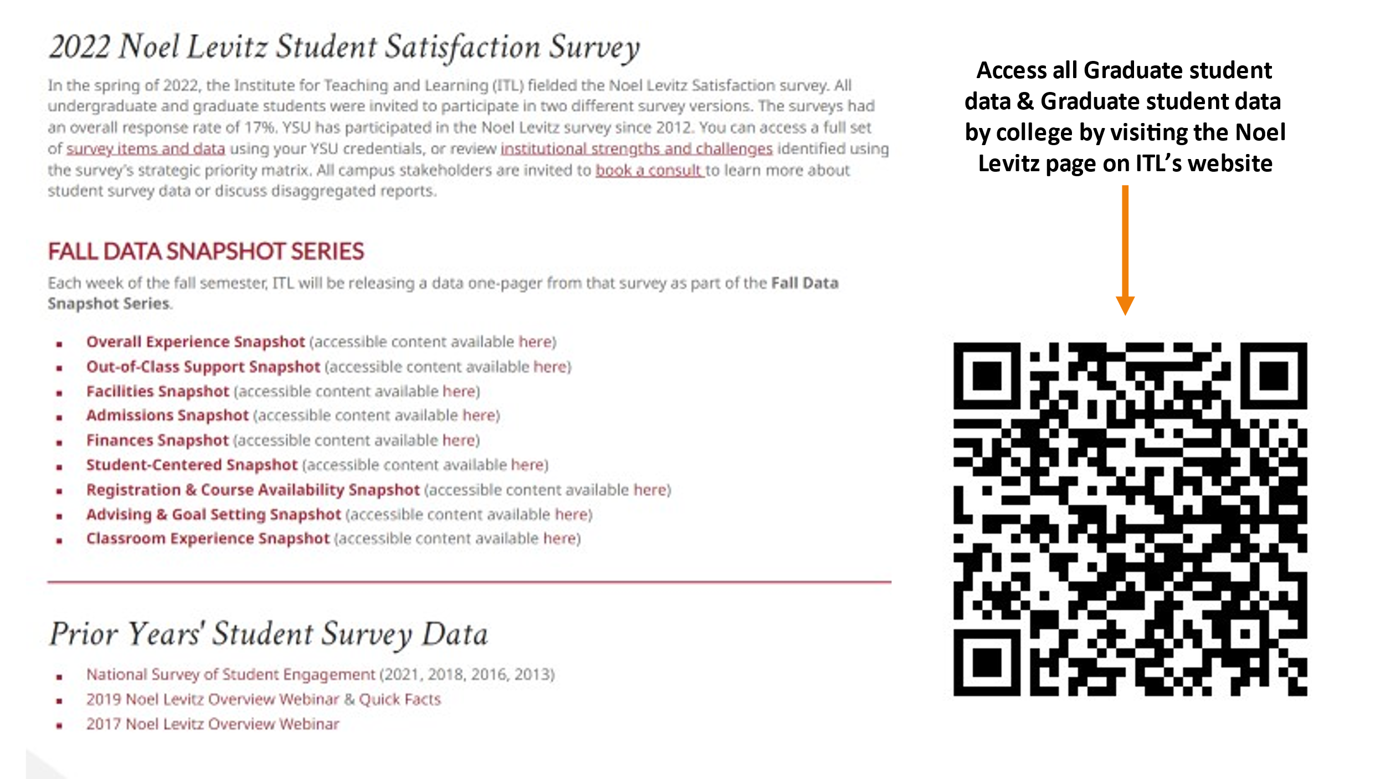

End of Hillary Fuhrman’s Presentation at Graduate Council on 3-29-2023.

///

